Student Names | ID Number
Fatima Ahmed Alhanfoosh
Lojain Talib Alghareeb
Farah Isa Aljokam
Yasmin Khalid Alshabaan
Eman Yassen

Table of Content
Supervised by: Ms. Ruba Mahmoud Ahmed Al-salah
Submission Date: 3/5/2025

CIS326 – IT Infrastructure Management-
Section 6F02 - Group 5
Topology Number 15
Department of Computer Science and Information Technology Second Semester
Academic Year (2024/2025)

Topology No.15 ……………………………………..…………………………….……….. 3 Introduction ………………………………………………..…………………….………… 4
Requirements Of The Topology ………………………………….…………….………….. 5
Set Up The Topology 15 …………………………………………………………………… 6
Addressing Table………………………………………………..……………………….….. 7
Assign A Dynamic IP Address …………………………………………………………....… 9
Vlans Configuration………………...……………………………………………..………… 11
WLC Configuration ………………………………..………………………………..……… 13
Configure Ripv2 And Ospf Routing ……………………………………………………….. 16
Redistribution………………………………………………………………………………. 19
Verify routing protocols……………………………………………………………………….20
Conclusion…………………………………………………………………………………. 22
Case Study ………………………………………………………………………………….. 23
References …………………………………………………………………………………..24

Topology No.15:
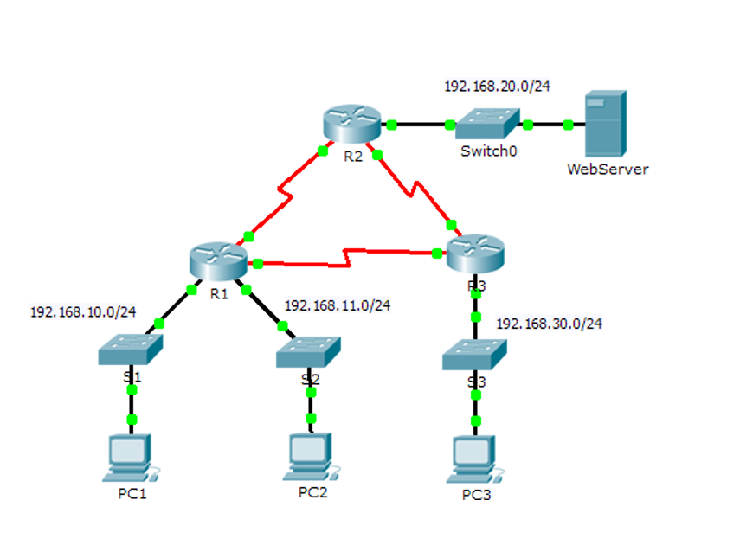

Introduction:

In this project, we designed a network infrastructure for a small hospital that spans three floors, each with multiple departments. The network ensures reliable communication, efficient routing, and scalable architecture. The design was implemented using Cisco Packet Tracer v7.1 and utilizes both RIP and OSPF routing protocols.

Requirements of the topology::

Device : | Quantity :
PC | 6
Laptop | 2
Tablet | 1
IP printer | 4
Cisco Switch | 4
Cisco Router | 3
Wireless LAN Controller (WLC) | 1
Lightweight Access Point | 1
Server | 1
UTP Cables | 16
Serial Cables | 2
 | 1
  Console Cable

Set Up The Topology:

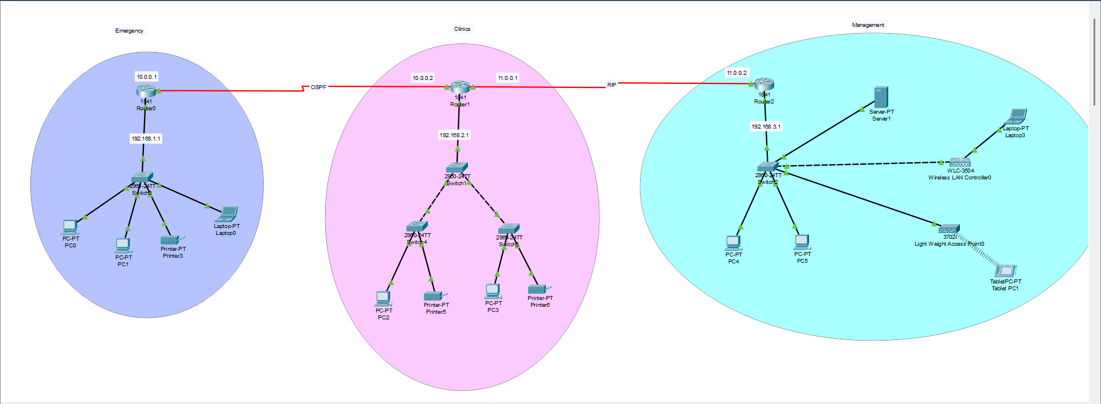

Addressing Table:

VLAN | Default Getaway | Subnet Mask | IP Address | Interface | Device  Name
VLAN10 | 192.168.1.1 | 255.255.255.0 | 192.168.1.2 | FastEthernet0 | PC0 (Emergency)
VLAN10 | 192.168.1.1 | 255.255.255.0 | 192.168.1.3 | FastEthernet0 | PC1 (Emergency)
VLAN20 | 192.168.2.1 | 255.255.255.0 | 192.168.2.2 | FastEthernet0 | PC2 (Clinics)
VLAN20 | 192.168.2.1 | 255.255.255.0 | 192.168.2.4 | FastEthernet0 | PC3 (Clinics)
VLAN30 | 192.168.3.1 | 255.255.255.0 | 192.168.3.2 | FastEthernet0 | PC4 (Management)
VLAN30 | 192.168.3.1 | 255.255.255.0 | 192.168.3.3 | FastEthernet0 | PC5 (Management)
- | - | 255.0.0.0 | 10.0.0.1 | Serial0/1/0
  Router0
- | - | 255.0.0.0 | 10.0.0.2 | Serial0/1/0 | Router1
- | - | 255.0.0.0 | 11.0.0.1 | Serial0/1/1 | Router1
- | - | 255.255.255.0 |  | FastEthernet0/1 | Router2
  192.168.4.1
- | - | 255.0.0.0 | 11.0.0.2 | Serial0/1/1 | Router2
VLAN10 | 192.168.1.1 | 255.255.255.0 | 192.168.1.8 | FastEthernet0
  Printer3
VLAN20 | 192.168.2.1 | 255.255.255.0 | 192.168.2.4 |  | Printer5
  FastEthernet0
VLAN20 | 192.168.2.1 | 255.255.255.0 | 192.168.2.5 | FastEthernet0 | Printer6
VLAN30 | 192.168.3.1 | 255.255.255.0 | 192.168.3.12 | FastEthernet0 | Server1
VLAN10 | 192.168.1.1 | 255.255.255.0 | 192.168.1.4 | FastEthernet0 | Laptop0
VLAN30 | 192.168.3.1 | 255.255.255.0 | 192.168.3.8 | FastEthernet0 | Laptop3
VLAN30 | 192.168.3.1 | 255.255.255.0 | 192.168.3.5 | Gig1 | WLC0
VLAN30 | 192.168.3.1 | 255.255.255.0 | 192.168.3.13 | Gig0 | Lightweight AP
VLAN30 | 192.168.3.1 | 255.255.255.0 | 192.168.3.15 | Wireless | Tablet0

Assign A dynamic IP Address Interface To the Tablet:

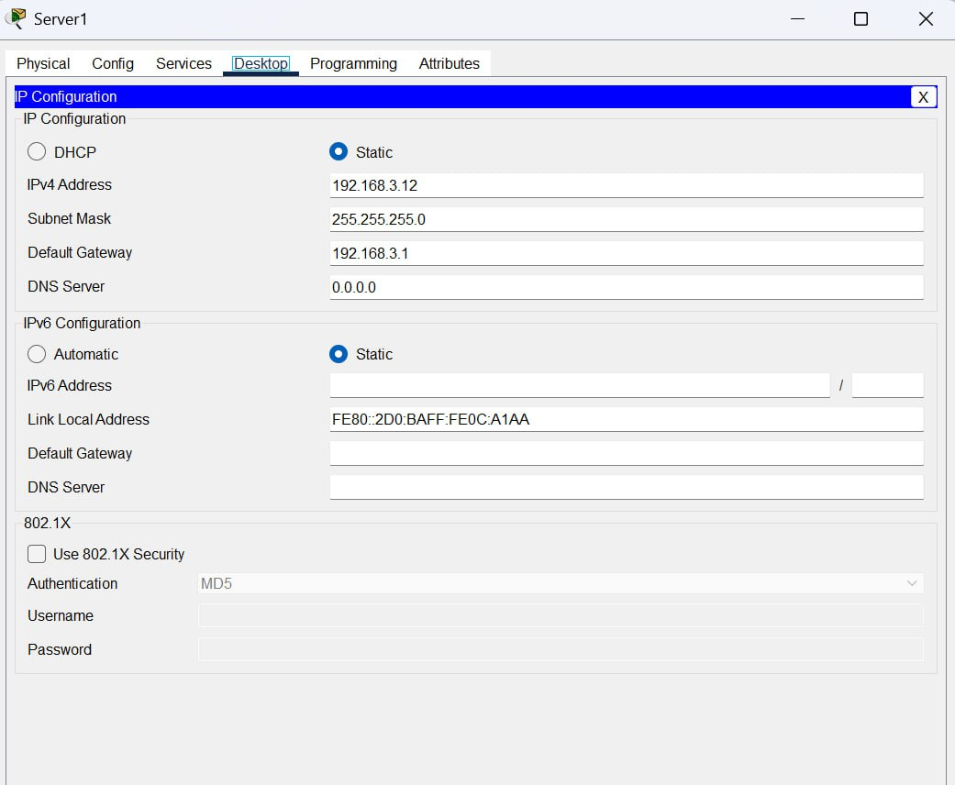
configure an IP address and subnet mask to the server .

services -> turning on DHCP and adding the network information :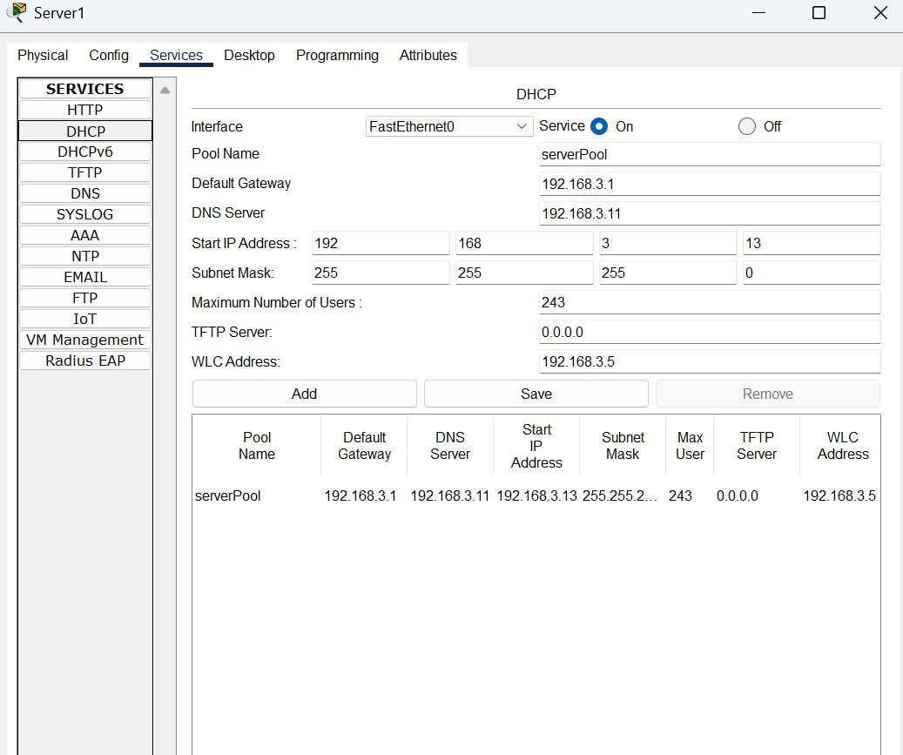
on the tablet -> desktop -> IP configuration -> choosing DHCP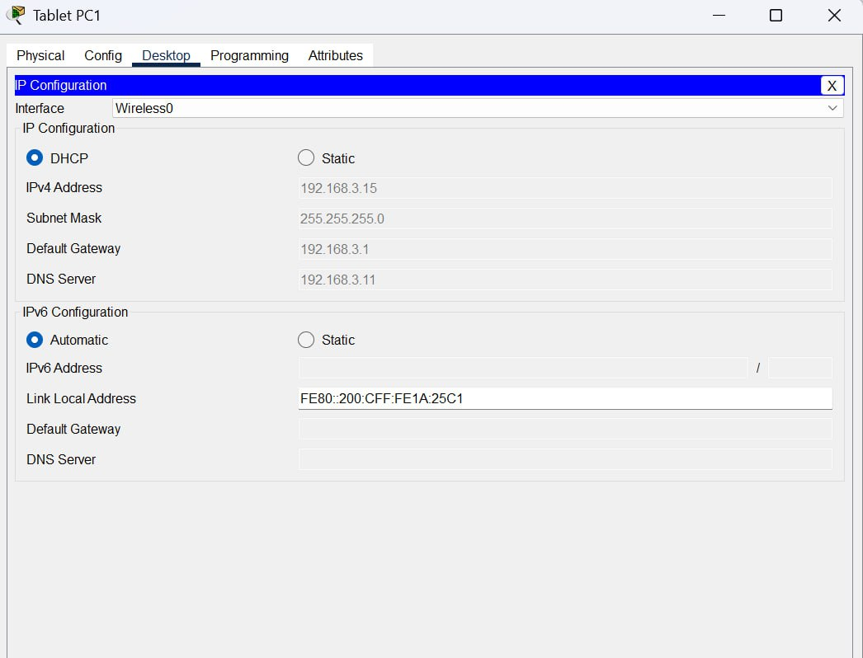

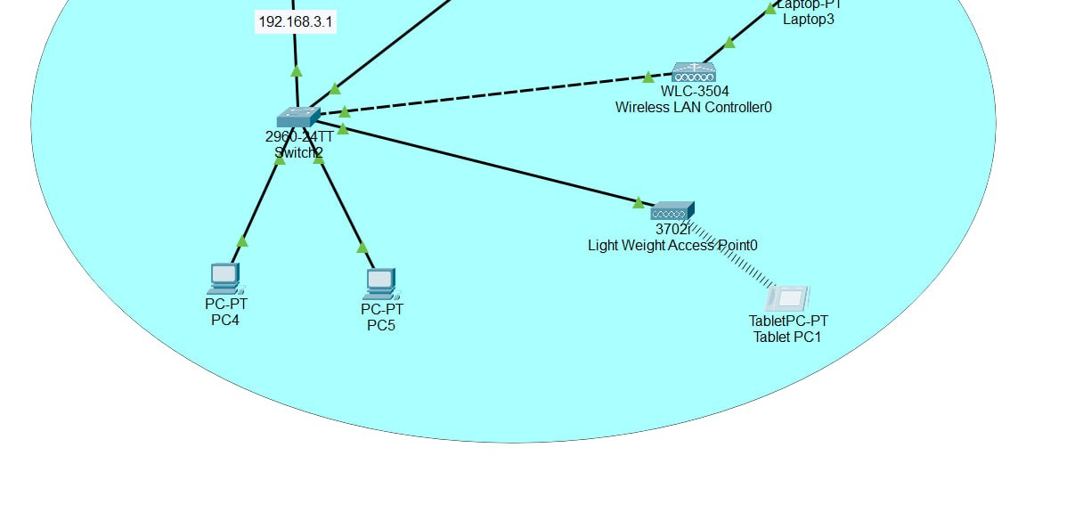

VLANs Configuration:

We create vlan number and name and assign switch ports to the valn

-Verify that the VLANs Have been created on Switch 0 :
Vlan name : pharma , vlan number : 10

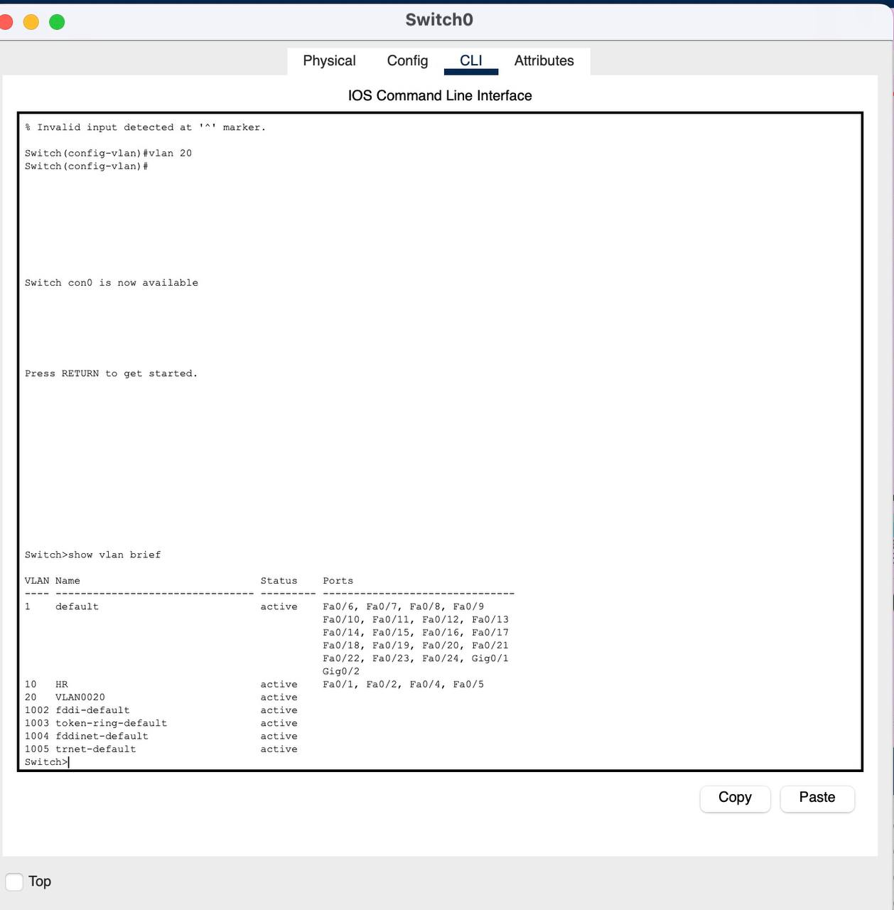

-Verify that the VLANs Have been created on Switch 1:
Vlan name : clinics , vlan number : 20

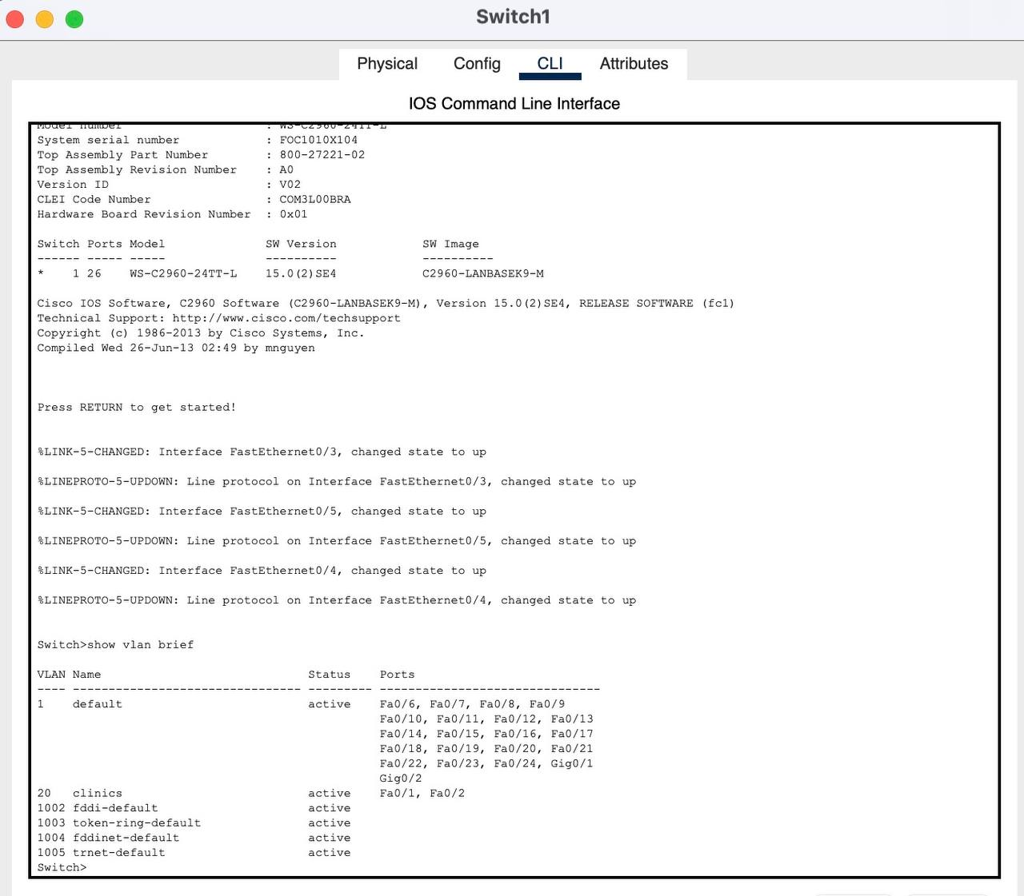

- Verify that the VLANs Have been created on Switch 2 :

Vlan name : ER , vlan number : 30

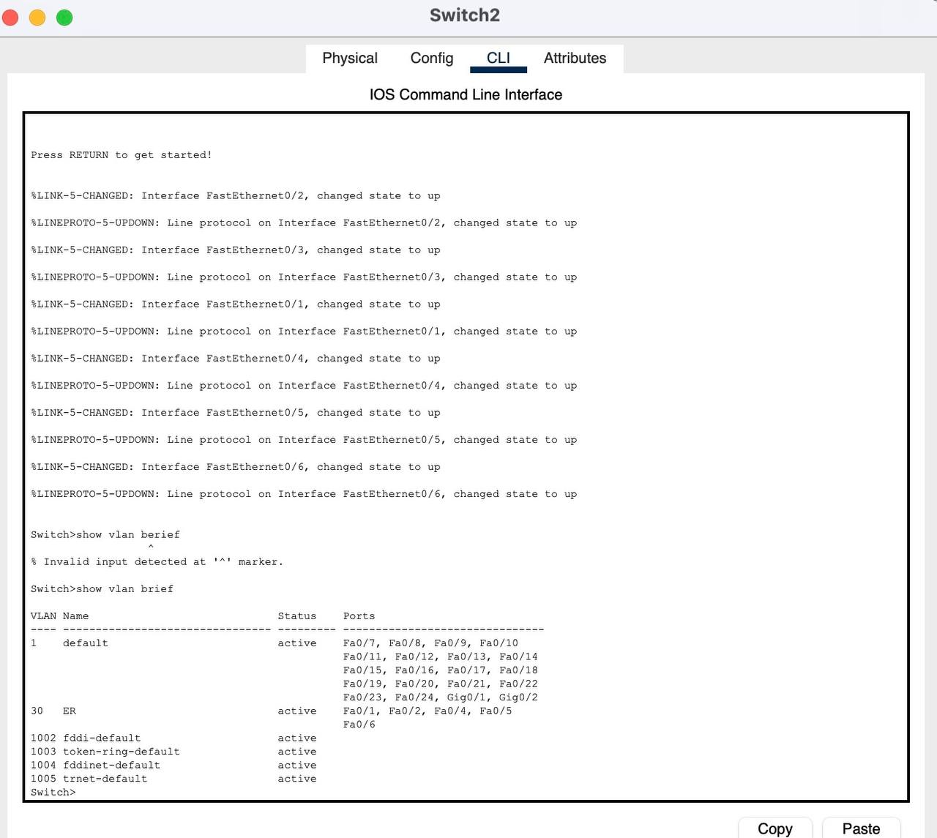

WLC Configuration:

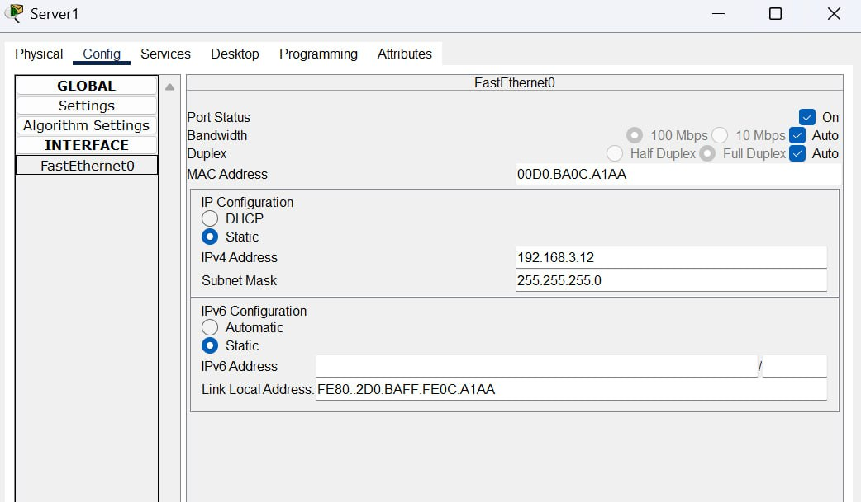
Server Configuration : IP address

Add services : DHCP configuration

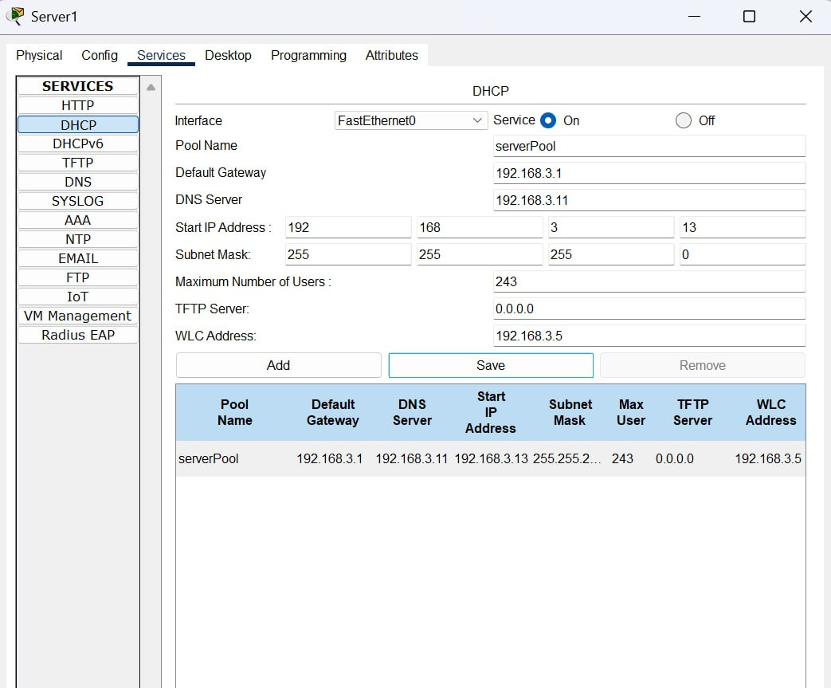

Addressing Wireless Lan Controller ( WLC )

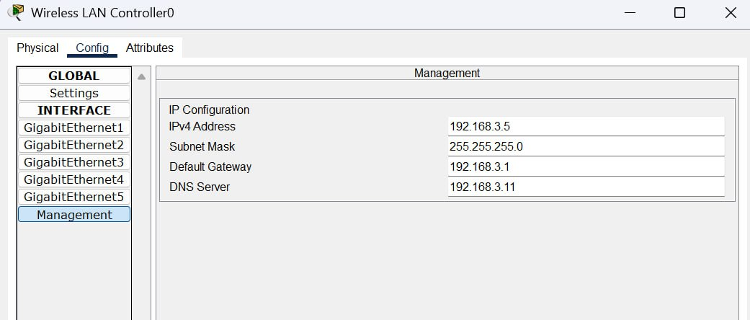

User name: Admin ,
Password : Admin123
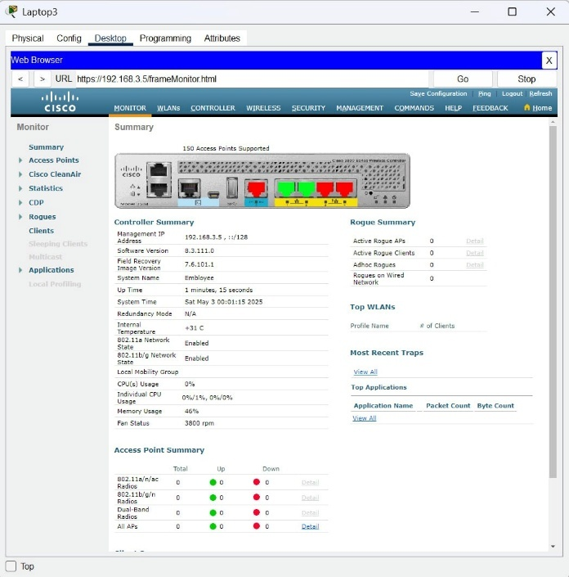
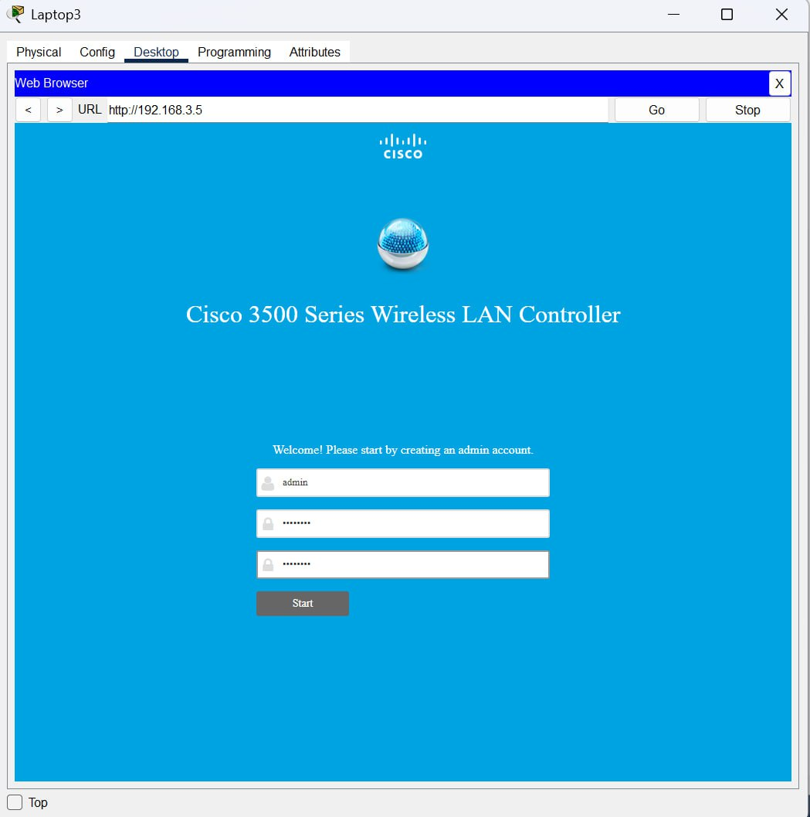

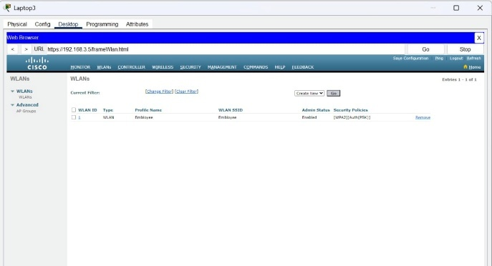
Re-access to the WLC using secure connection (Https) to see the previous configuration of WLANS and the connected Access Point (Wireless):
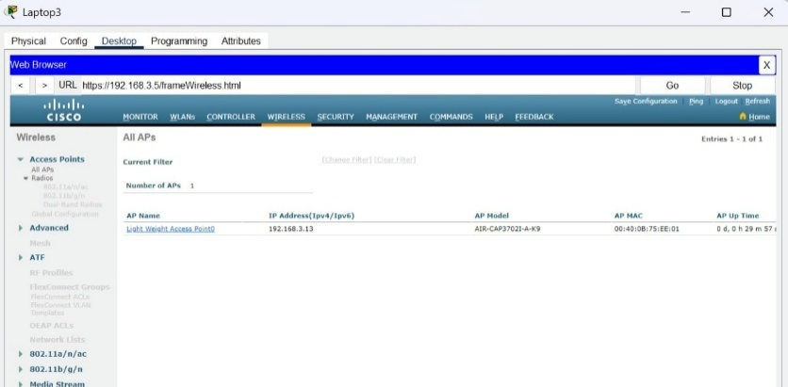

Connecting wireless device ( tablet ) to the WLAN (Employee ):

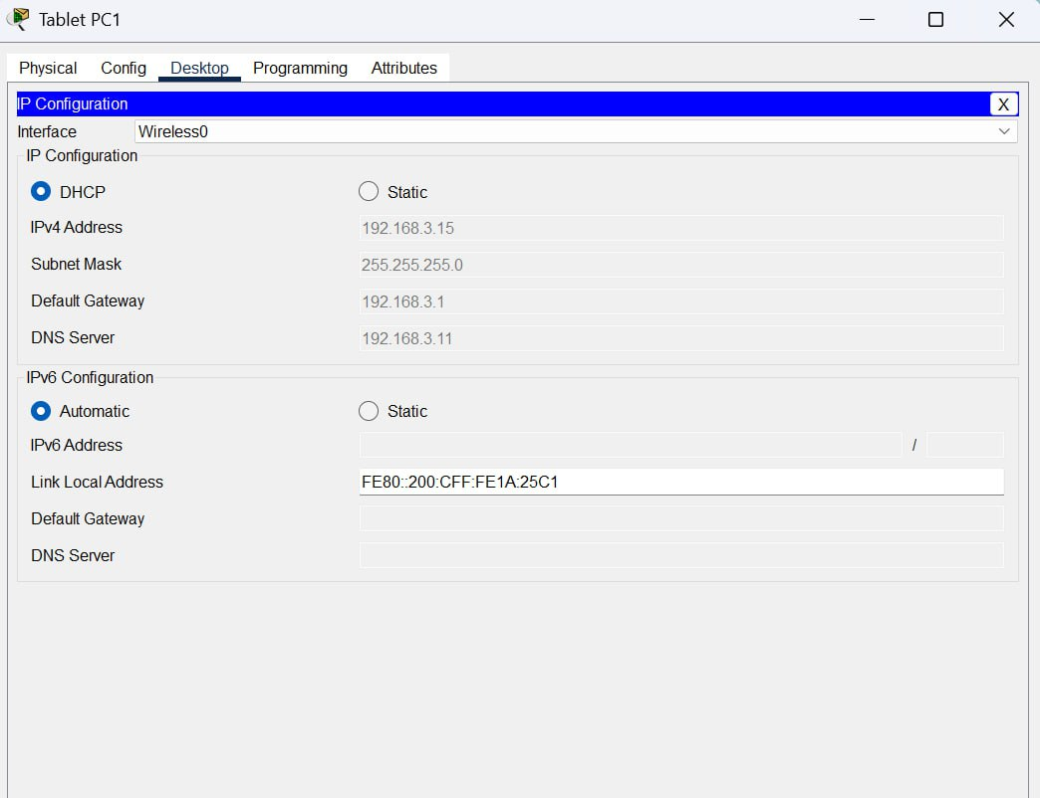
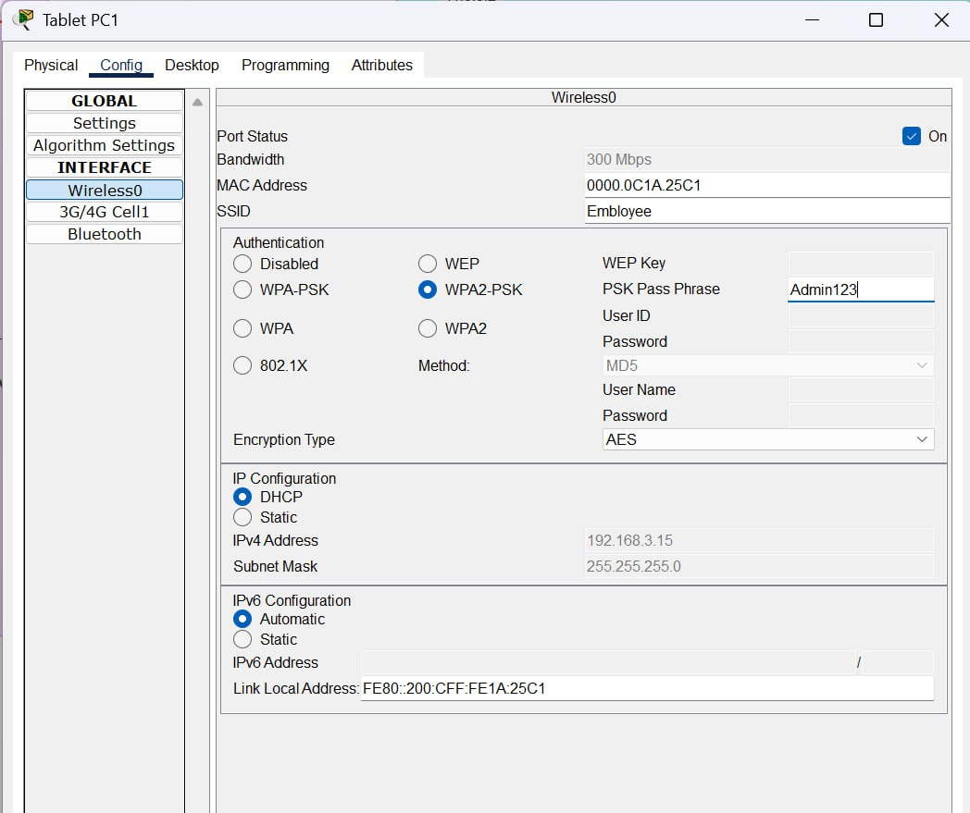

Configure RIPv2 and OSPF Routing :

Router0
We configured Router0 in OSPF routing protocol by using these commands :
enable
configure terminal
router ospf 1
network 192.168.1.0 0.0.0.255 area 0
network 10.0.0.0 0.0.0.255 area 0
exit

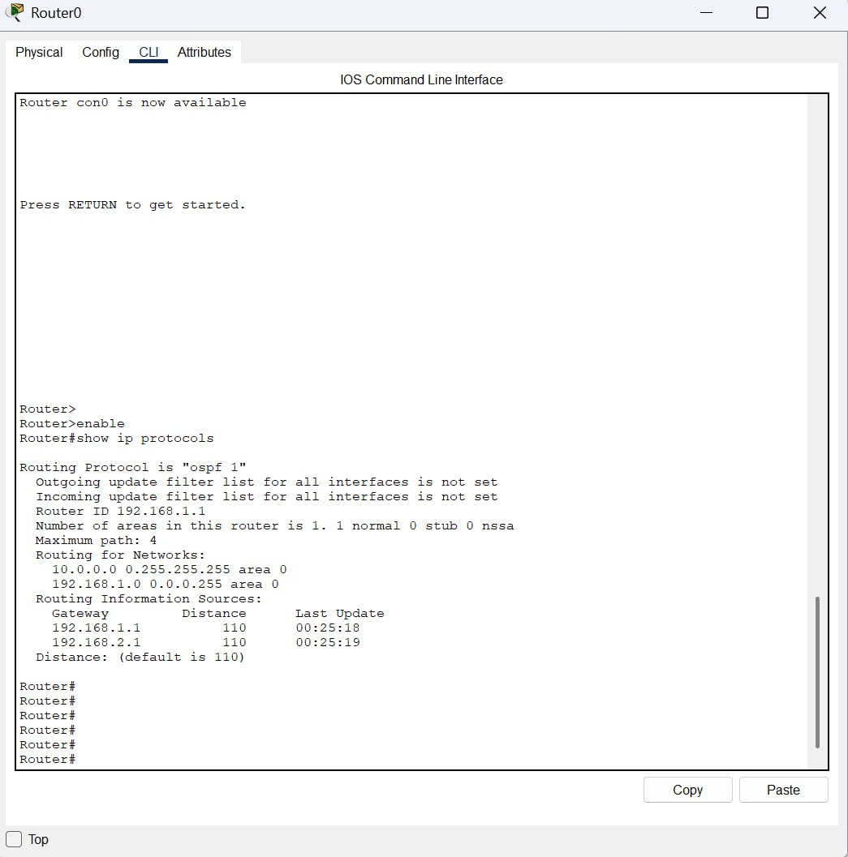

Router 1
We configured two routing protocol in Router 1 by using these commands:
OSPF

enable
configure terminal
router ospf 1
network 192.168.2.0 0.0.0.255 area 0
network 10.0.0.0 0.0.0.255 area 0
exit

RIP

enable
configure terminal
router rip version 2
network 11.0.0.0
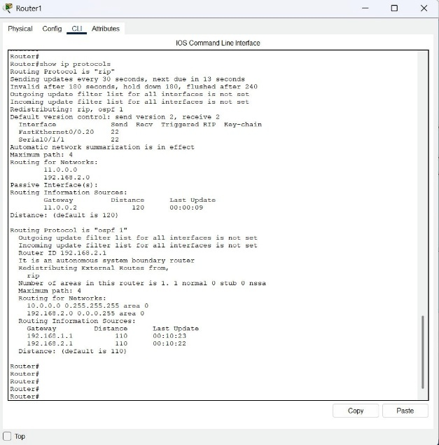
exit

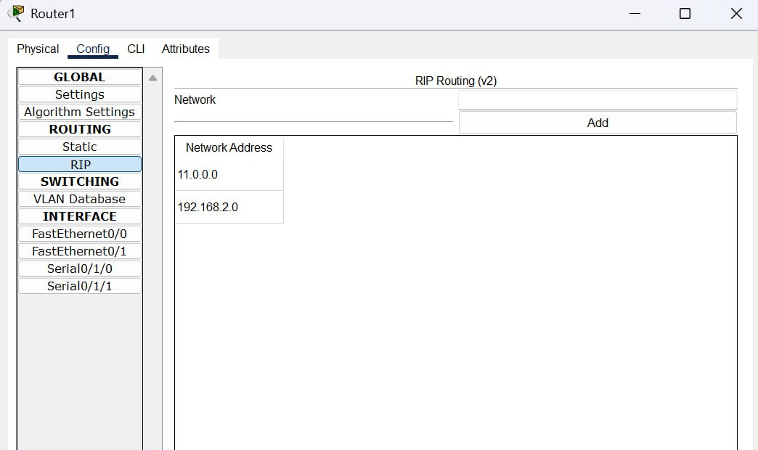

Router 2
We configured RIP routing protocol in Router2 by using these commands:

enable
Router(config)# router rip
Router(config-router)# version 2
Router(config-router)# network 11.0.0.0
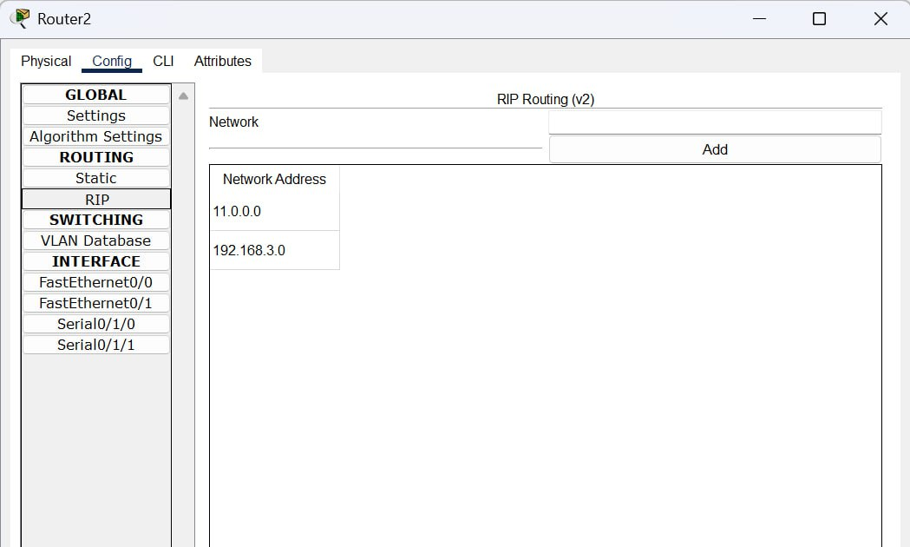
Router(config-router)# network 192.168.3.0

Redistribution RIP & OSPF :

We used the route redistribution in Router 1 to allows routes from one routing protocol to be advertised in another routing protocol

We used the following command in Router 1:
Router ospf 1
Redistribute rip subnets
Exit

Router rip
Redistribute OSPF metric 10
Exit

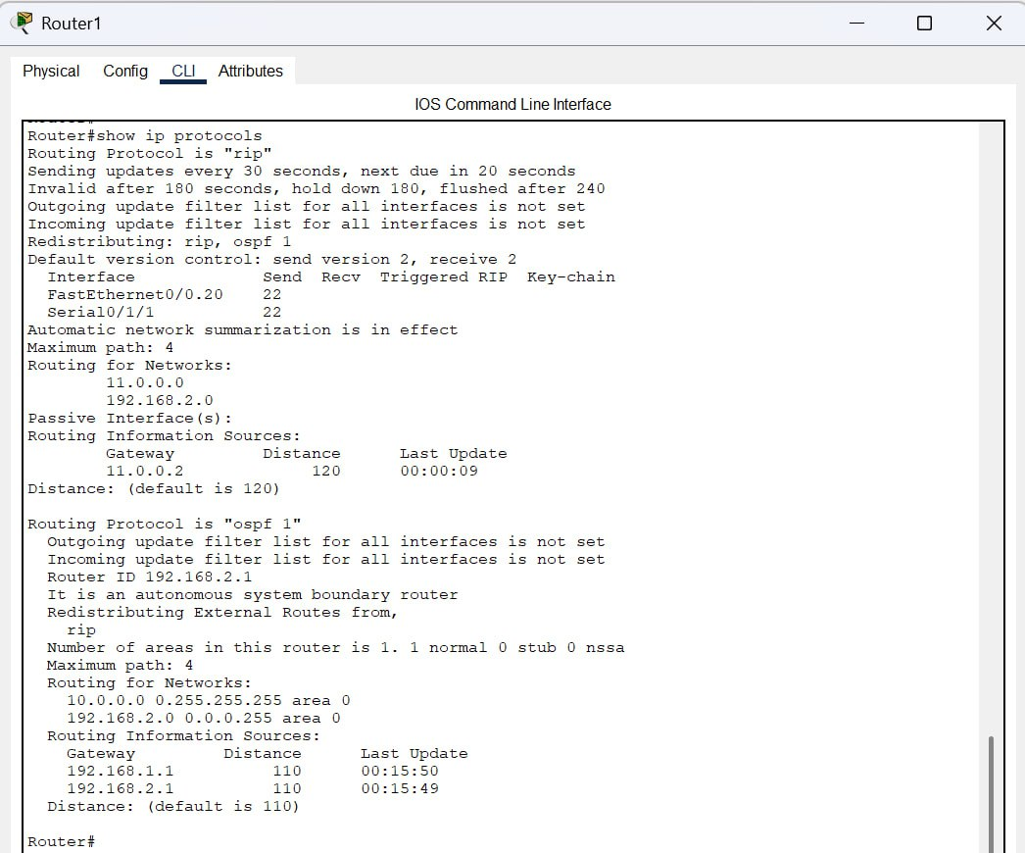

Verify routing protocols :

We used “show ip rout” command to view the routing table on all the routers:

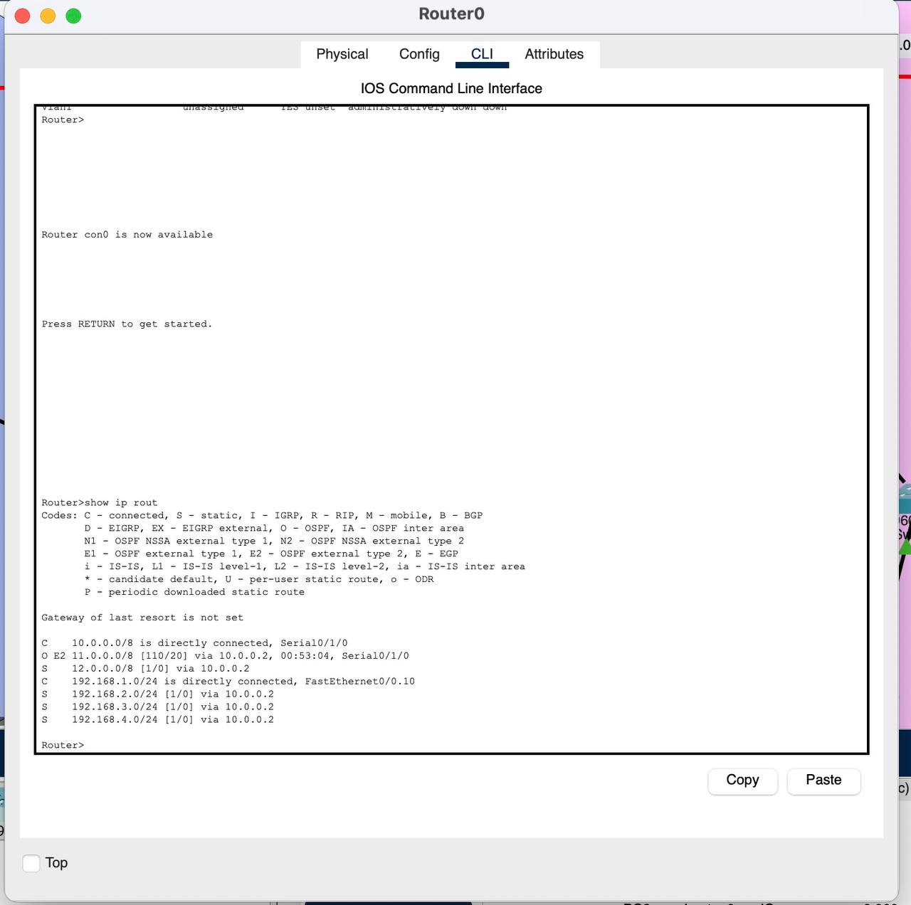
Router0:

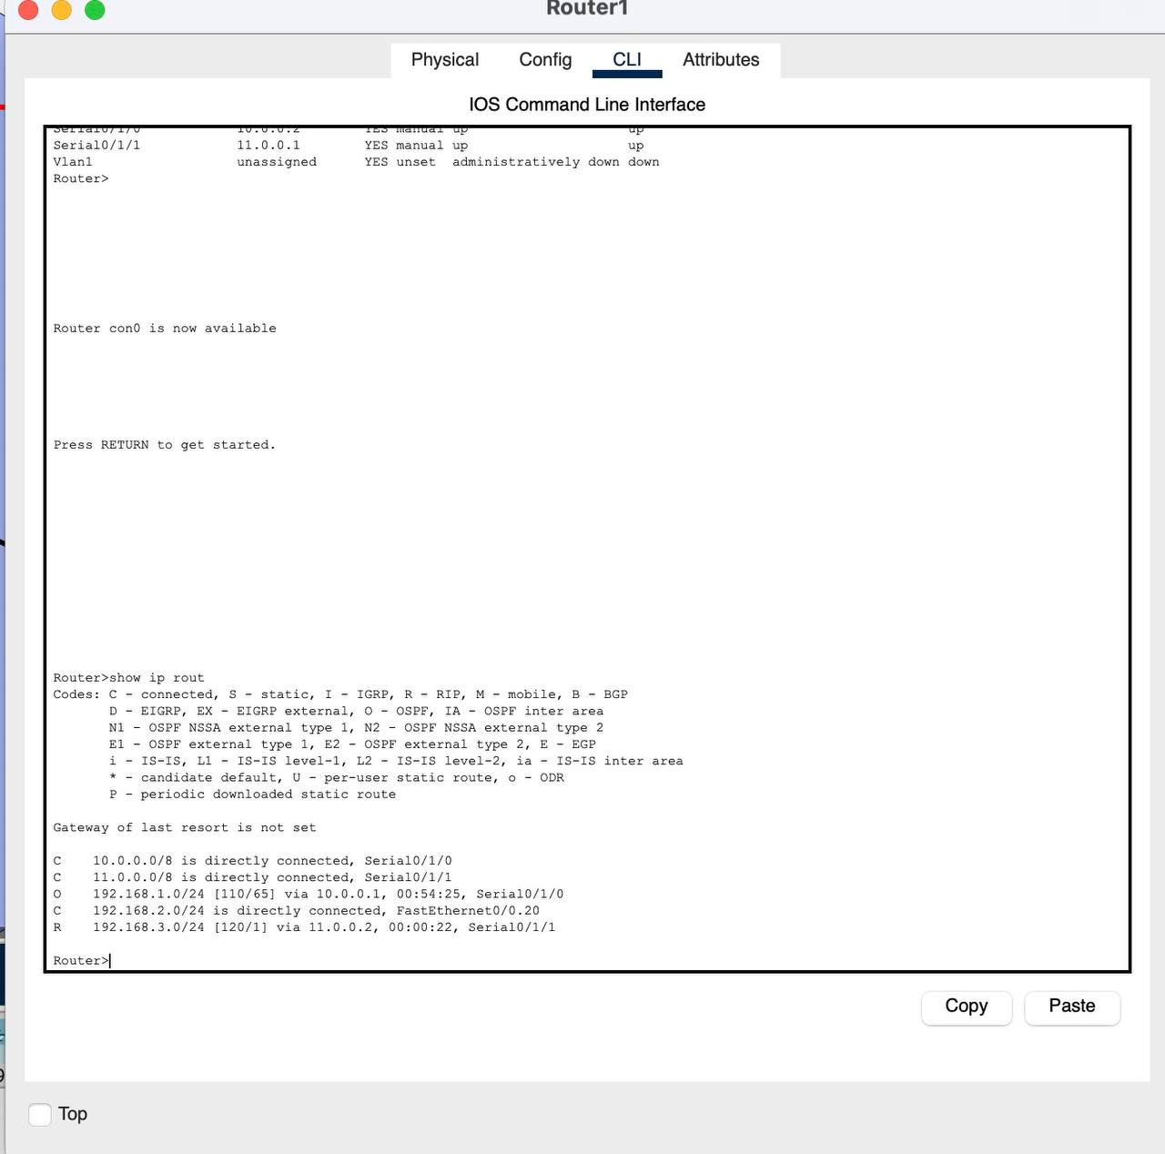
Router 1 :

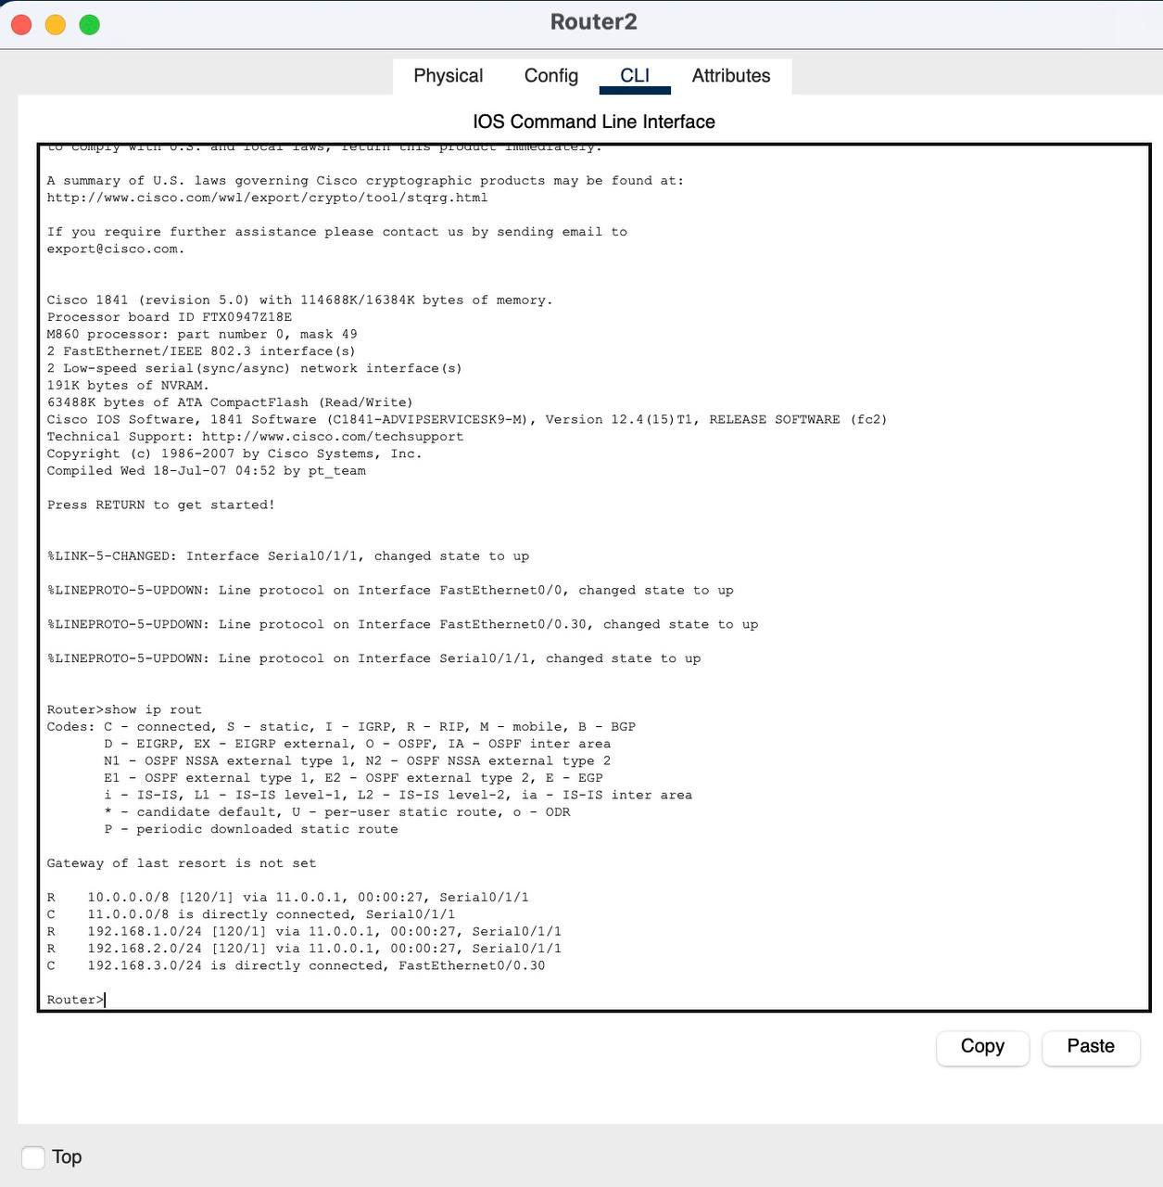
Router 2 :

Successful Ping :

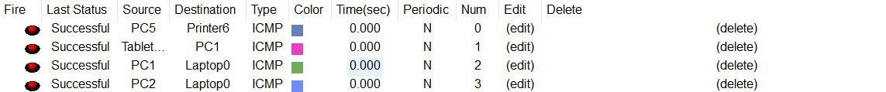

Conclusion

The designed hospital network meets all the specified requirements, supports redundancy, and ensures secure access to services across three floors. Routing, VLANs, and wireless were successfully implemented and verified.

Case Study:
Cloud Service Provider: Amazon Web Services (AWS)
As an IT expert hired to modernize the digital infrastructure of a private hospital in Riyadh, I recommended migrating their patient records and medical imaging data to Amazon Web Services (AWS). The hospital was struggling with limited on-premise storage, high maintenance costs, and no disaster recovery plan. By adopting AWS, we designed a cloud-based solution that enhanced performance, scalability, and data security.

i. Concept of Cloud Computing
Cloud computing is the on-demand availability of computing resources—like servers, storage, and databases—delivered over the Internet. It allows institutions to scale resources quickly without investing in physical infrastructure.

ii. Its Models and Usage Areas
AWS provides all major cloud models:
- IaaS: Using Amazon EC2, the hospital runs virtual servers for their management systems.
- PaaS: With AWS Elastic Beanstalk, developers deployed web apps for patient portals.
- SaaS: Services like Amazon WorkDocs helped streamline collaboration among medical staff.
Common usage areas include healthcare, finance, education, e-commerce, and artificial intelligence.

iii. How Does Cloud Computing Work?
The hospital connects securely to AWS’s regional data centers via the Internet. AWS dynamically allocates virtual resources based on system load, and ensures 24/7 availability through redundant availability zones. All medical data is encrypted and stored across multiple physical locations for backup and compliance.

iv. What Cloud-Computing Services Are Available?
AWS offers 200+ services. For the hospital, we used:
- Amazon S3: For storing MRI and lab results.
- Amazon RDS: For patient records in a secure database.
- AWS IAM: To control staff access based on roles.
- Amazon EC2: For hosting hospital management software.

v. How Is AWS Different from Other Cloud Providers?
Compared to Azure and Google Cloud, AWS provides:
- The widest global infrastructure and availability zones.
- More mature services, especially in healthcare and AI.
- Stronger compliance certifications (HIPAA, GDPR).
This made AWS the most reliable choice for storing sensitive patient data and ensuring business continuity.

References

- Amazon Web Services. (n.d.). What is cloud computing? https://aws.amazon.com/what-is-cloud-computing/
- Rouse, M. (2023). Cloud computing service models. TechTarget. https://www.techtarget.com/searchcloudcomputing/definition/cloud-computing
- Amazon Web Services. (n.d.). Global infrastructure. https://aws.amazon.com/about-aws/global-infrastructure/
- Amazon Web Services. (n.d.). AWS Products. https://aws.amazon.com/products/
- Gartner. (2023). Magic Quadrant for Cloud Infrastructure and Platform Services.
- Synergy Research Group. (2024). Cloud market share Q4 2023.

